**Servo controls experiment**

The servo is a position servo drive. It is made up of casing, circuit board, coreless motor, gear and position detector. The working principle is that the receiver or the single chip sends a signal to the servo. It has a reference circuit inside which can generate a reference signal with a period of 20ms and a width of 1.5ms. And compare the bias voltage with the potentiometer’ s voltage to obtain a voltage difference output. The rotation direction is judged by the IC on the circuit board, and then the coreless motor is driven to start rotating, and the power is transmitted to the swing arm through the reduction gear, and the position detector returns a signal to determine whether the positioning has been reached. Suitable for control systems that require constant angles of change and can be maintained. When the motor speed is constant, the potentiometer is rotated by the cascade reduction gear, so that the voltage difference is 0, and the motor stops rotating. Generally, the angle of rotation of the steering gear ranges from 0 to 180 °.

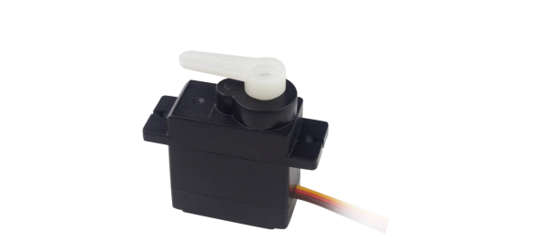

There are many specifications for the servo, but all the servo has three external wires. The brand has a variety of colors to distinguish the servo:

|  |  |  |
| --- | --- | --- |
| GND | VCC+ | Signal |
| black | black | white |
| black | red | white |
| brown | red | orange |

The servo number of our robot arm from upper (paw) to lower (rotational station) is from small to large, 1-N.

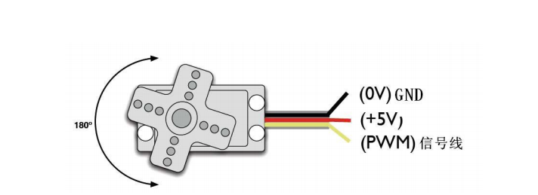

Signal line

The angle of rotation of the servo is achieved by adjusting the duty cycle of the PWM (Pulse Width Modulation) signal. The standard PWM (Pulse Width Modulation) signal has a period of 20ms (50Hz). Theoretically, the pulse width distribution should be between 1ms and 2ms. However, in fact, the pulse width can be between 0.5ms and 2.5ms, and the pulse width corresponds to the rotation angle of the servo from 0°to 180°. It is worth noting that, depending on the servo brand, the angle of rotation of the servo of different brands will be different for the same signal.

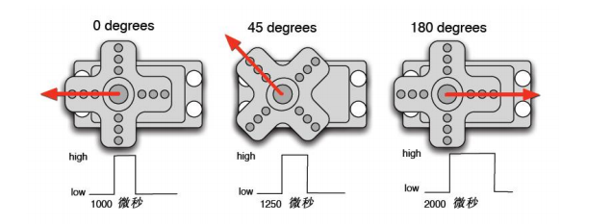

2000 Microseconds

1250 Microseconds

1000 Microseconds

After understanding the basics, we can learn how to control a servo. The components required for this experiment rarely, only one servo and jumper.

Servo*1pcs

Breadboard jumper*1set

There are two ways to control Arduino. One is to bring a square wave with different duty cycles through the Arduino's common digital sensor interface, and simulate produce a PWM signal for servo positioning, the other is to directly use the Arduino's own Servo function to control the servos. The advantage of this control method is that the programming . The disadvantage is that it can only control the 2 channel servo. Because the Arduino own function can only use the digital port 9, 10 . The Arduino has limited drive capability, so an external power supply is required when it is necessary to control more than one servo.

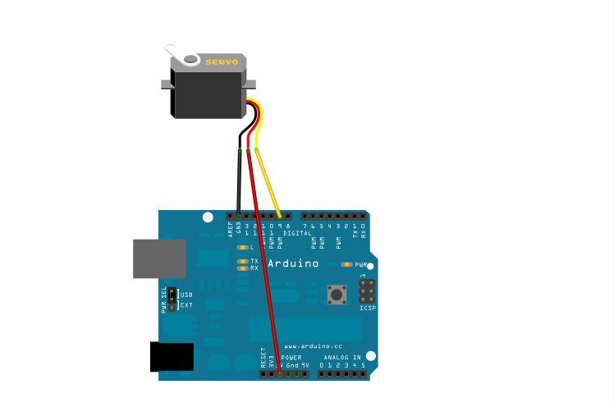

Connect servo to NO.9 port

Edit a program that causes the servo to rotate to the position of the number of angles corresponding to the user input number. And display the angle on the screen.

Reference source program

#include <Servo.h>

Servo myservo; // define servo objects, up to eight

int pos = 0; // define servo position

void setup()

{

myservo.attach(9); // set servo control pin

}

void loop()

{

// 180°to 0°rotation servo, 15 milliseconds per delay

for(pos = 0; pos < 180; pos += 1)

{

myservo.write(pos);

delay(15);

}

// 180°to 0°rotation servo, 15 milliseconds per delay

for(pos = 180; pos>=1; pos-=1)

{

myservo.write(pos);

delay(15);

}

}

Experimental phenomena:

After uploading to Arduino, you can see that the servo starts to run from 0 to 180 and then from 180 to 0.

Expand the experiment:

1. It is so simple to control a servo. Is it more fun to control multiple?